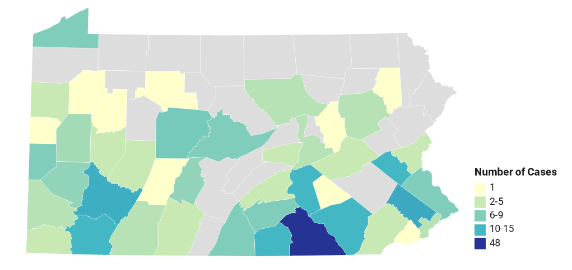





June 2020
Prevalence of NPS Benzodiazepines in Impaired Driving and Death Investigation Casework in Pennsylvania (USA)
Cases by County in Pennsylvania
NPS Benzodiazepines (aka Designer Benzodiazepines) are
synthetic manufactured drugs.


DUID |  |  | Postmortem
Year | New Cases | Incidence (per 1,000 persons)* | Deaths | Mortality (per 1,000 persons)*
2017 | 23 | 0.0018 | 8 | 0.00055
2018 | 42 | 0.00328 | 15 | 0.00117
2019 | 99 | 0.00773 | 17 | 0.00133
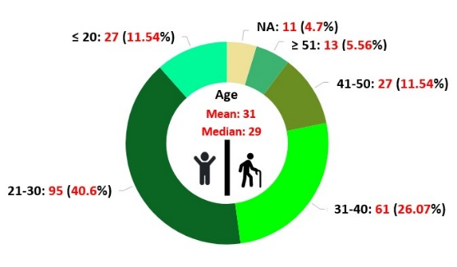
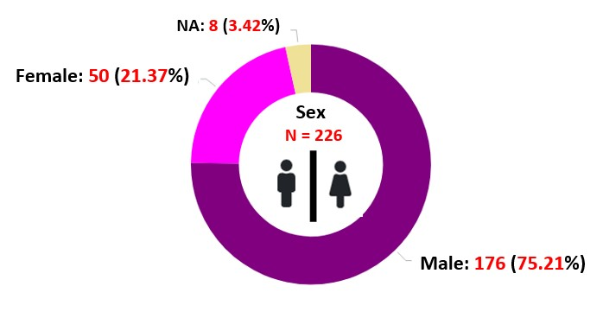
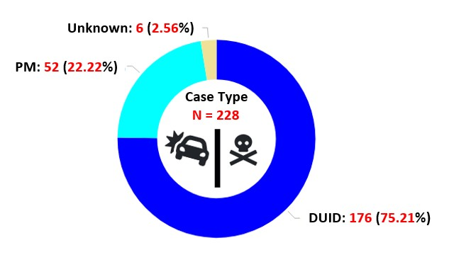

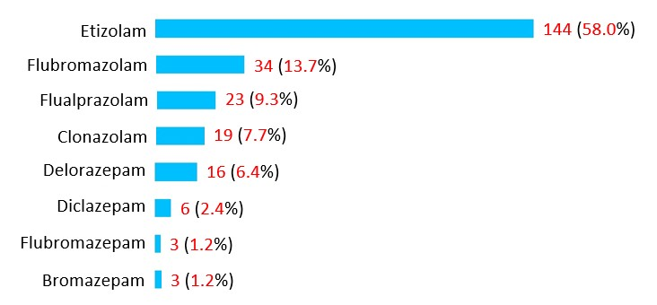
*Census statistics for Pennsylvania used in calculation
Limitations: Data is based on samples received at NMS Labs, and may not be fully representative of the
statistics for Pennsylvania.
Acknowledgements:
This report was prepared by Alex J. Krotulski, PhD; Tiffany Chan, MPH; Donna M. Papsun, MS, D-ABFT; and Barry K. Logan, PhD, F-ABFT.
Data were provided by NMS Labs for analysis and graphic depiction at CFSRE.
Case Type, Gender, and Age
Common symptoms of NPS:
 
Strong Sedation Amnesia
Additional effects:
- Loss of coordination (Ataxia)
- Minor Respiratory Distress
- Drowsiness
- Dizziness
- Blurred Vision
- Slurred Speech
- Can Result in Death

Benzodiazepine Varieties and Frequencies
Measuring the Occurrence of DUID and Postmortem Cases
Declaration: Geographical distribution may be limited by location of submitting agencies and not necessarily representative of all jurisdictions.
References and Related Articles:
• Logan, BK. et al. (2017) Reports of Adverse Events Associated With Use of Novel Psychoactive Substances, 2013-2016: A Review. J Anal Toxicol. 41(7): 573-610
• Flualprazolam: Potent Benzodiazepine Identified Among Death & Impaired Driving Cases in the U.S. Public Alert, NPS Discovery, December 2019.

